COMP828: Week 1 Quiz

23205919 Ricky Yang(GuangLiang Yang)

2024-03-07

### 1. Perform the following calculations in R/RStudio using this R markdown template and write your R code in the code chunk provided:

$\frac{2+1}{2^{3×1}}+5$

* $x=\sqrt{10}$ and $y=1−\frac{1}{1+x}$. Find the value for $y$

x <- (2 + 1) / (2^(3*1)) + 5  
x

## [1] 5.375

x <- sqrt(10)  
y <- 1 - (1 / (1 + x))  
y

## [1] 0.7597469

### 2. Write the R code (in the code chunk provided) to find the descriptiopn of the “plot” function.

# Write your R code here  
?plot

## Help on topic 'plot' was found in the following packages:  
##   
## Package Library  
## graphics /Library/Frameworks/R.framework/Versions/4.3-x86_64/Resources/library  
## base /Library/Frameworks/R.framework/Resources/library  
##   
##   
## Using the first match ...

### 3. Generate the variables w and z using the R code below. Then, make the plot of w against z (i.e., on the xy plane). Write your R code in the code chunk provided.

w <- rnorm(50)

z <- rnorm(w)

# Write your R code here  
w <- rnorm(50)  
z <- rnorm(w)  
plot(w,z)

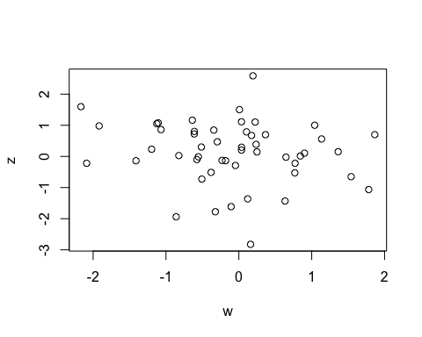

### 4. Generate a sequence of even numbers from 0 to 20. Then, make it as a 5x2 matrix.

# Write your R code here  
s <- seq(2, 20, by=2)  
  
m <- matrix(s, nrow=5, ncol=2, byrow=TRUE)  
m

## [,1] [,2]  
## [1,] 2 4  
## [2,] 6 8  
## [3,] 10 12  
## [4,] 14 16  
## [5,] 18 20

### 5. Find the dimension of the matrix in 4.

# Write your R code here  
s <- seq(2, 20, by=2)  
  
m <- matrix(s, nrow=5, ncol=2, byrow=TRUE)  
md <- dim(m)  
md

## [1] 5 2